SOLEDGE2D-EIRENE User guide

**CEA**

**[Adresse de la société]**

**[N° de téléphone]**

**[N° de télécopie]**

**[Choisir la date]**

Hugo BUFFERAND

Step by step from grid generation to post-treatment

SOLEDGE2D-EIRENE grid generator

## Determining domain topology and boundaries

1. **Load a magnetic equilibrium file**

The grid generator expects to load a matlab (.mat) file containing:

* The magnetic flux psi as a 2D table in R, Z named as flux2D
* The radius R in meter as a 2D table named r2D
* The vertical coordinate Z in meter as a 2D table named z2D
* The horizontal magnetic field Br in Tesla as a 2D table named Br2D
* The vertical magnetic field Bz in Tesla as a 2D table named Bz2D
* The toroidal magnetic field Bphi in Tesla as a 2D table named Bphi2D

The magnetic flux is expected to be growing from the core to the wall.

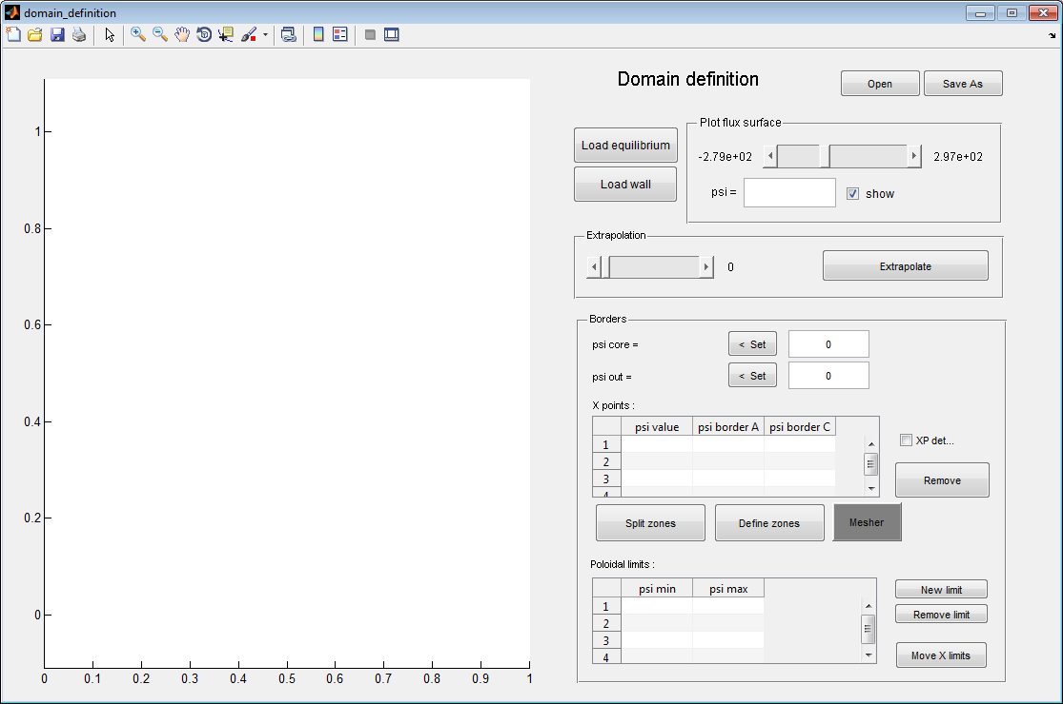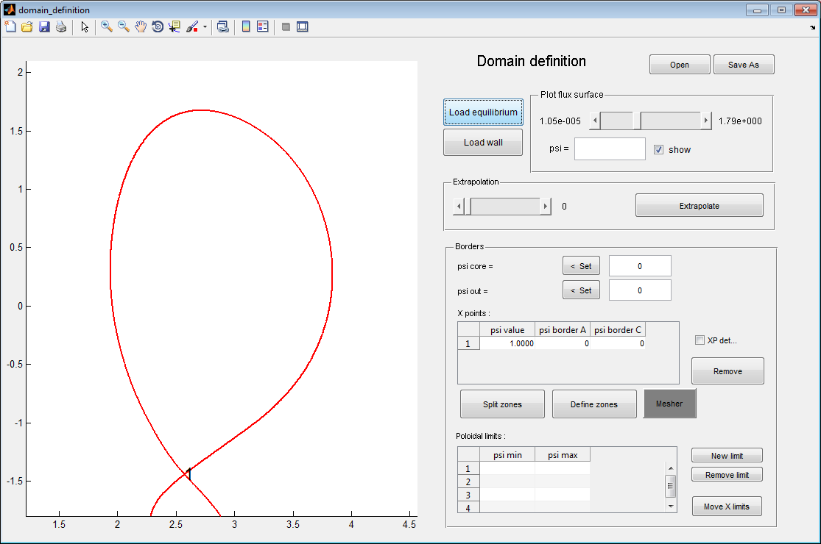

Once the equilibrium file is loaded, the X-points are automatically detected and separatrix plotted. X-points characteristics are displayed in the X-points table in the Borders panel.

1. **Load wall geometry**

The wall geometry must be stored in a matlab file (.mat) containing:

* The R coordinate in meter in a 1D vector named Rwall
* The Z coordinate in meter in a 1D vector named Zwall

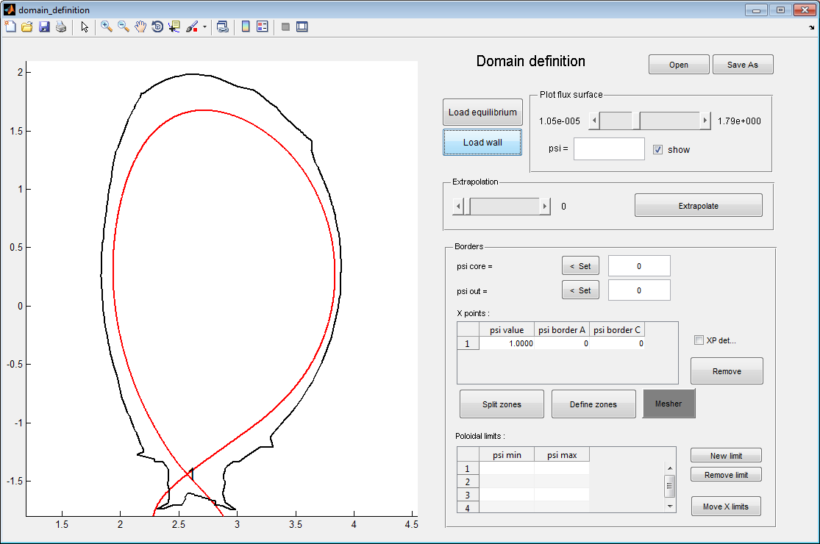

1. **Determining main radial limits for the grid**

Radial limits for the grid must be set. In particular, one must define the first flux surface of the grid in the core region (button and text box circled in green). One must also determine a flux surface in the wall to delimit the most outer flux surface of the grid (bouton and text box circled in red). This flux surface must contain the whole wall contour if one wants to simulate the entire volume of plasma up to the wall.

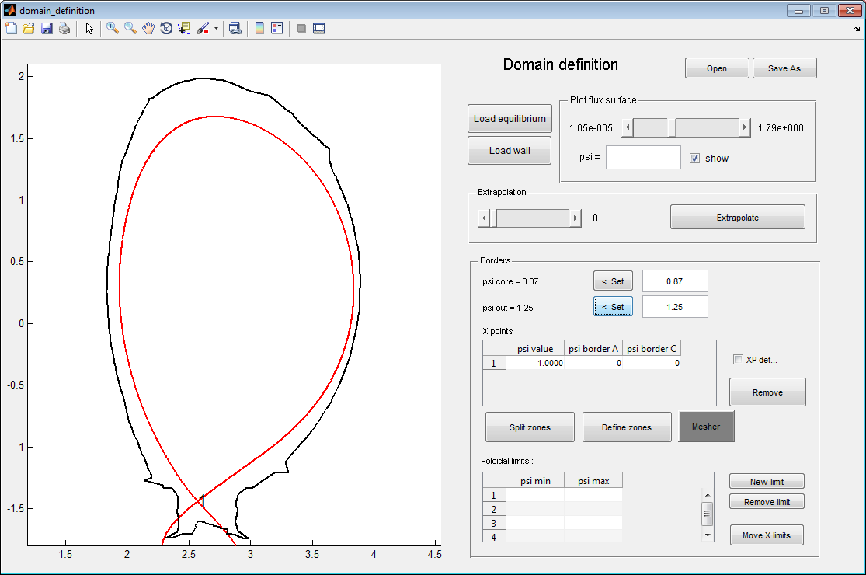

If necessary, the flux map can be extrapolated using the extrapolate button. Psi surface can be plotted by setting a value in the psi text box and by activating the “show” check box in the “Plot flux surface” panel.

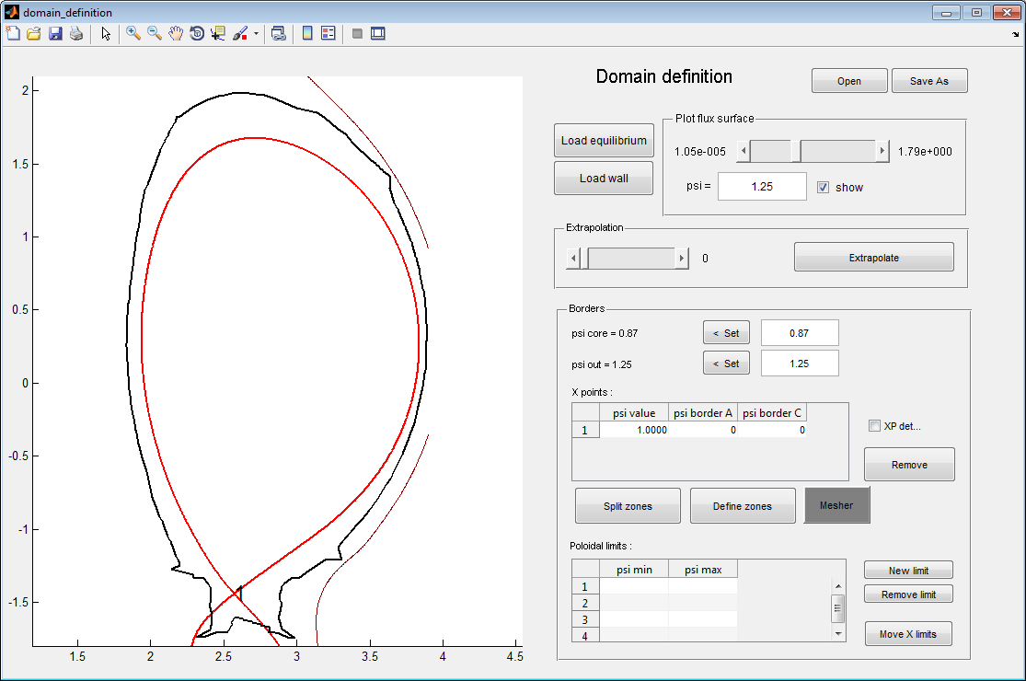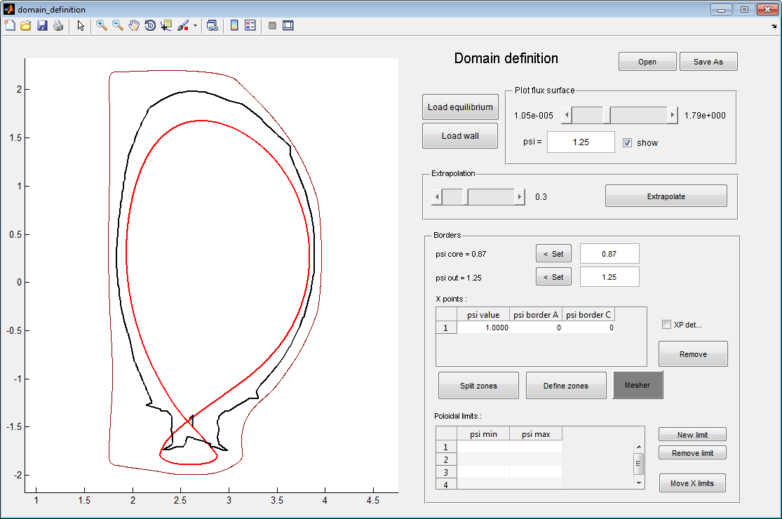

*Before extrapolation: the flux surface psi=1.25 does not contain the wall*

*After extrapolation: the flux surface psi=1.25 contains the wall*

1. **Determining radial limits around X-points**

From each X-point must be generated 4 branches labeled A, B, C and D. These letters can be displayed by checking the XP details check box in the border panel. Each of these branches determines a poloidal split of the new mesh. They start at the psi-value of the X-point and terminate at a psi-value that must be determined. For branch B and D, one assumes that branches terminate for psi=psiwall. For branch A and C, a value must be provided manually in the X-point table.

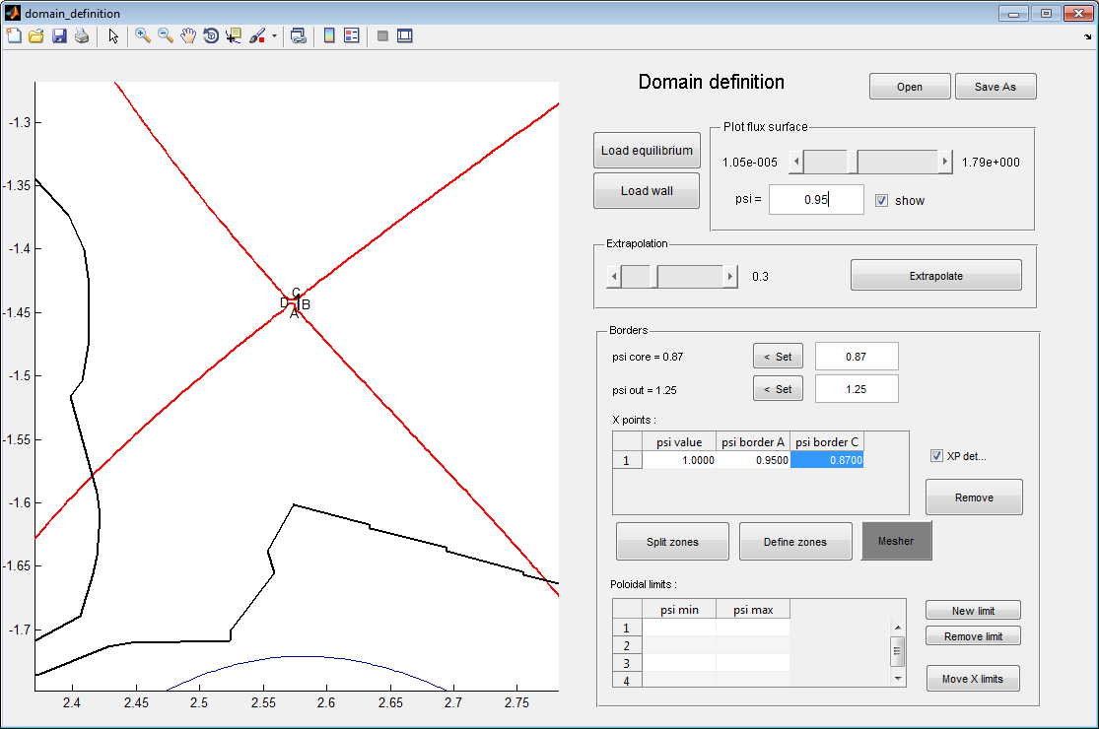

*X-point details showing direction in which poloidal branches will be created*

*X-point table where radial limits are set for branches starting from X-point*

Flux surface psi=0.95

Limit for branch A of X-point 1

Once the radial limits are set, the “split zones” button can be pressed to calculate branches generated from X-points.

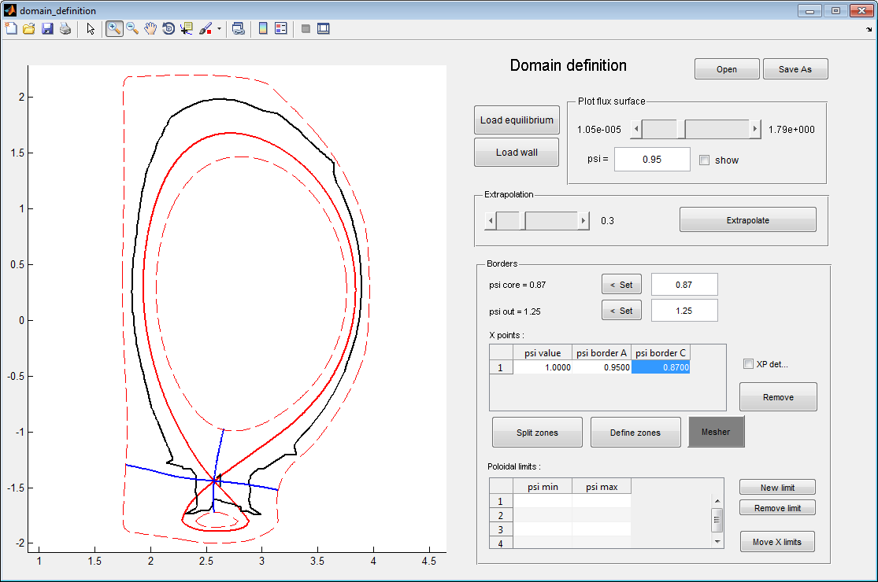

*Branches generated from X-point that will determine future domain decomposition*

1. **Determining extra poloidal limits (limits not associated with X-points)**

In order to finish domain decomposition, one must provide a poloidal limit for each divertor leg. This limit is made of line segments created by pressing the “new limit” button. The line segments must cover the radial extent between the red dashed lines surrounding the divertor. An example is shown below for the JET case consider here.

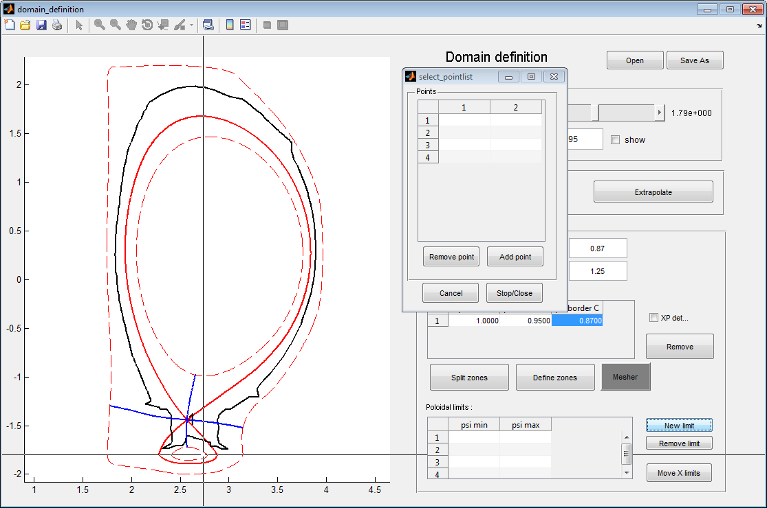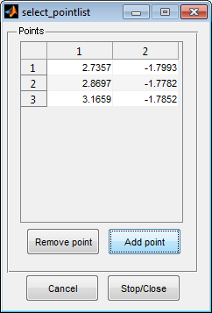

Cross-hair to select points determing the line segment limit

Add as many points as necessary to draw the limit (2 or 3 points are usually necessary)

When done, press Stop/Close to save the limit

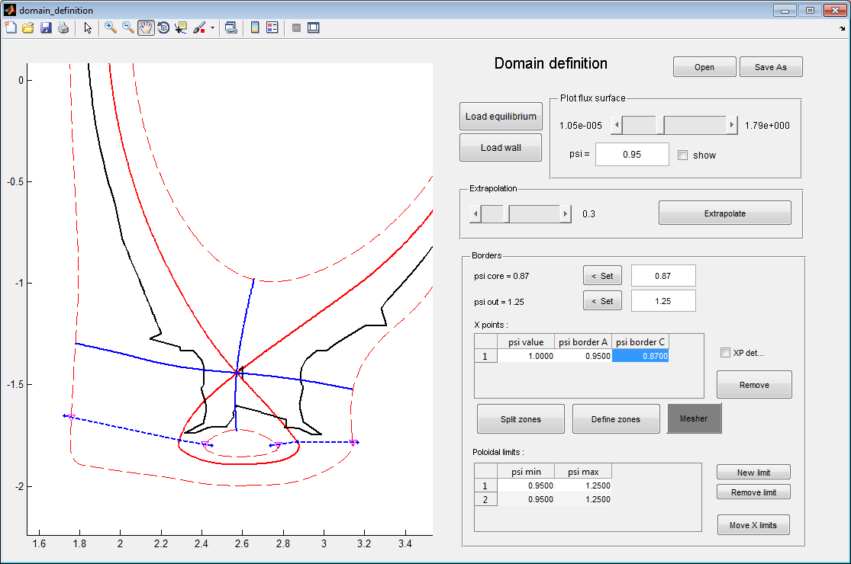

Two limits have been defined, one for each divertor leg. They both cross the two red dashed line defining radial limits around the leg. Intersections between radial and poloidal borders are shown with a magenta triangle. The limits must in principle be outside the plasma.

1. **Domain decomposition**

Once the poloidal limits defined, the “Define zones” button can be pressed. As a result, the zone domain decomposition must be displayed as well as zone neighboring table. The mesher window is also open to move to next step.

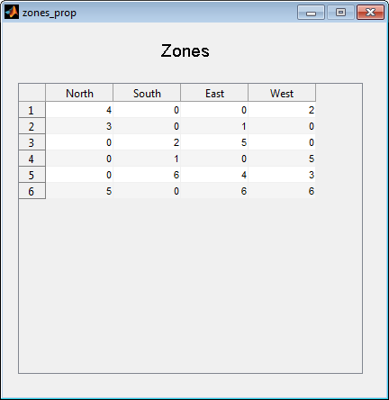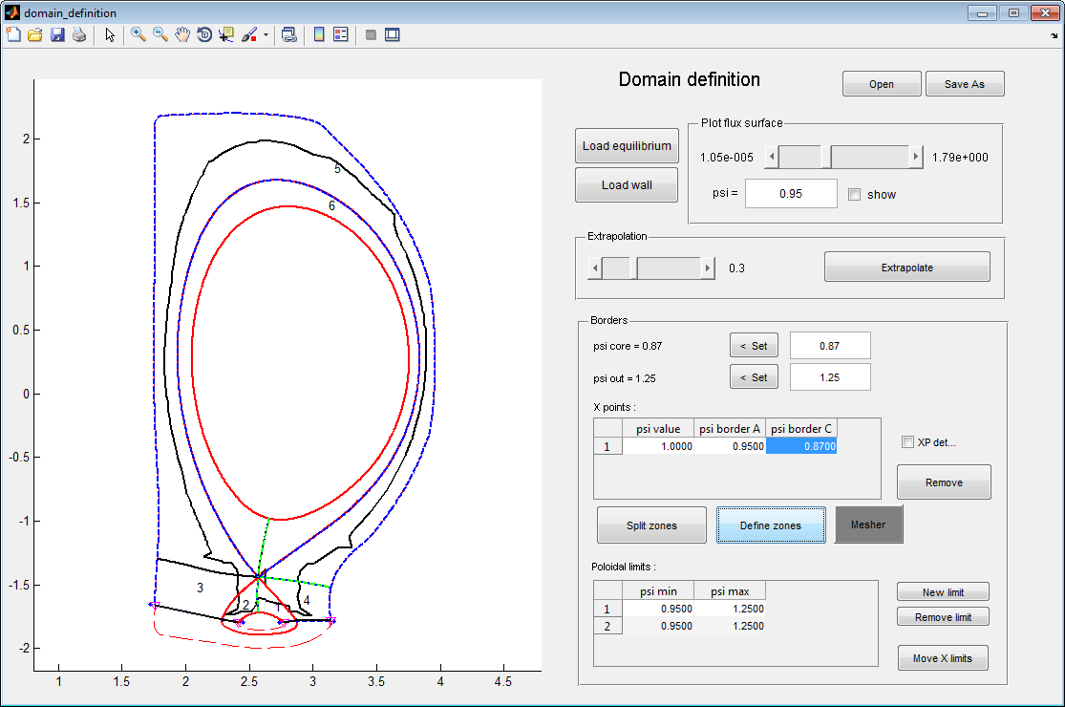

Zone number

Zone neighboring window: North-South is related to the radial direction (South-to-North corresponding to low-to-high psi values). East-West is related to the poloidal direction. 0 is shown when no neighboring zone can be found.

## Meshing the zones

In the mesher window, one is invited to select segment and mesh them by defining:

* A number of points
* A way to position points on the segments
* An optional alignment of the mesh with the wall around a particular segment and over a given radial extent.

At the beginning, all segments are unmeshed and thus displayed in red. They turn green as they are progressively meshed. To mesh a segment, select it by clicking the “select segment” button. For a basic mesh, select “none” in the Refinement panel, enter a number of points in the Segment mesher text box and click the “Mesh” button. A regular number of points is plotted on the segment. All connected segments are turned green.

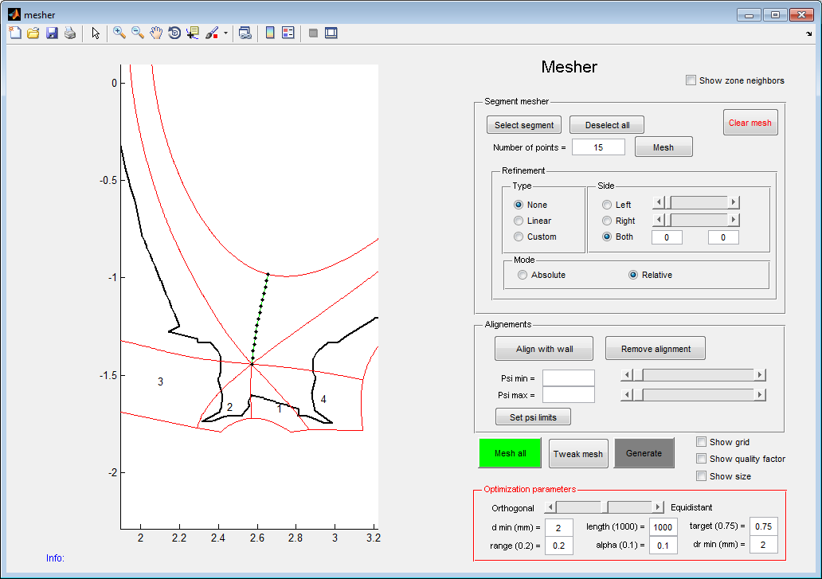

Segment meshed using basic setting (constant spacing). Number of points set to 15 in the Segment mesher text box (green circle)

Around X-point, in the radial direction, it can be useful to use a non-constant spacing between points. It is better to increase mesh size near the X-point where the flux expansion is important in order to avoid having to small meshes in the mid-plane. Mesh spacing can also be increased for points in the wall. To do so, use the “custom” option in the Refinement panel. A new window opens where one can adjust the point spacing by hand and display resulting flux surfaces.

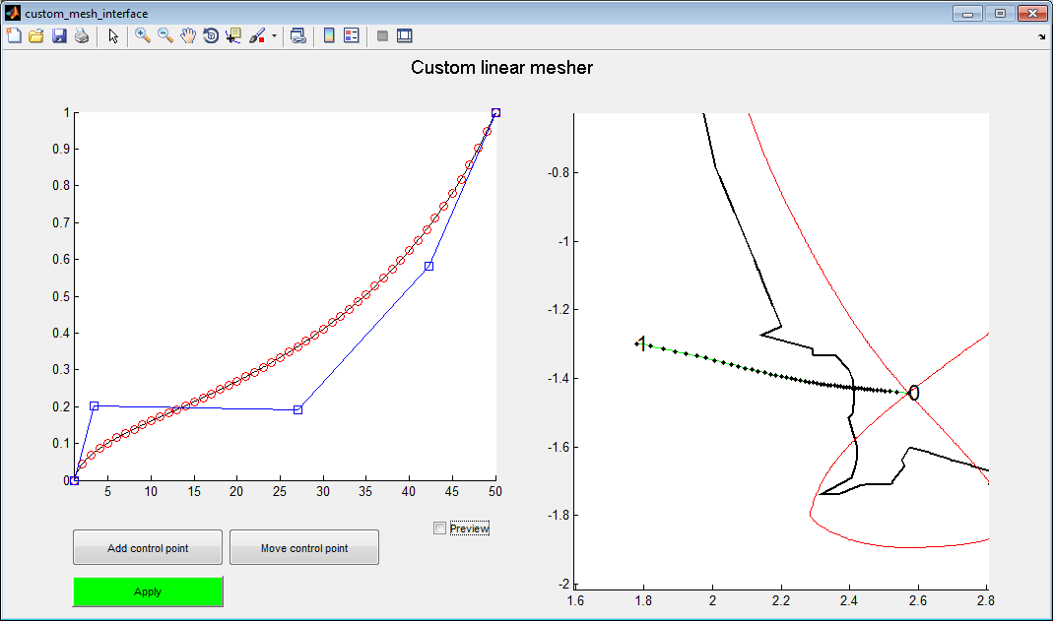

The repartition of grid points can be adjusted adding and moving control points of the Bezier line in the left panel figure. On the right panel, grid points are plotted. Flux surfaces can be plotted by checking the “preview” check box.

For the divertor legs, it can be better to align the mesh with the wall on a specified radial extent. Doing this helps reducing errors due to penalization interpolations of fluxes on the wall. To align the mesh, click on the segment to mesh and then press the “Align with wall” button. The segment is splitted in two sub-segments: one between the X-point and the wall, one between the wall and the poloidal limit outside the plasma. Each sub-segment can be meshed independently. The radial extent on which the mesh must be aligned must be specified by adjusting the sliders and then pressing the “set psi limits” button.

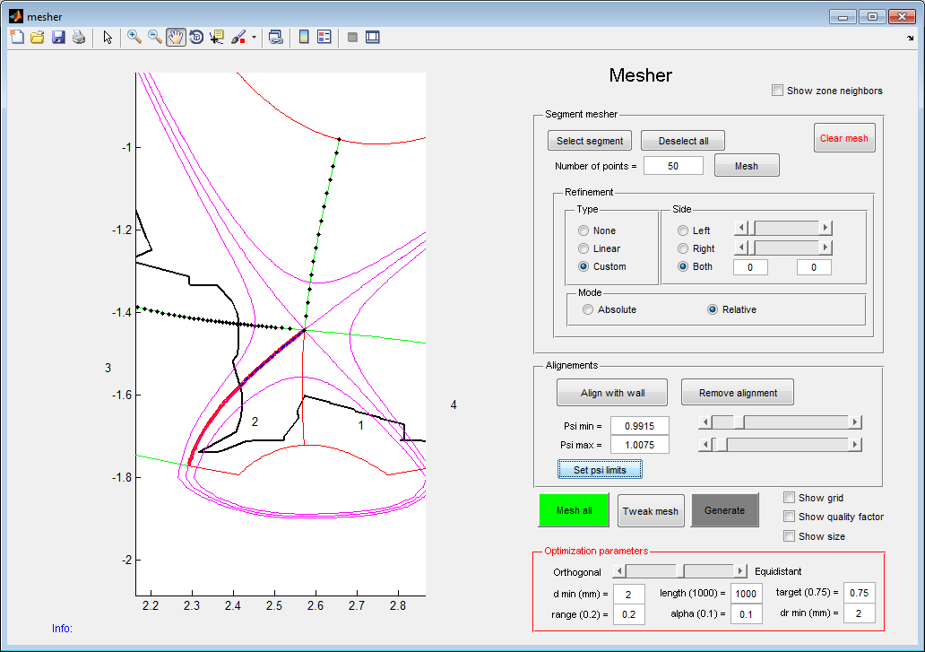

Definition of mesh alignment is made using the sliders. The flux surfaces between which the grid is aligned with the wall are plotted in magenta.

In order to refine grid spacing near the wall, used the “Linear” option in the Refinement panel. Choose which side you want the grid to be refined. Select “absolute” mode to specify the grid spacing in centimeters where you want the grid to be refined.

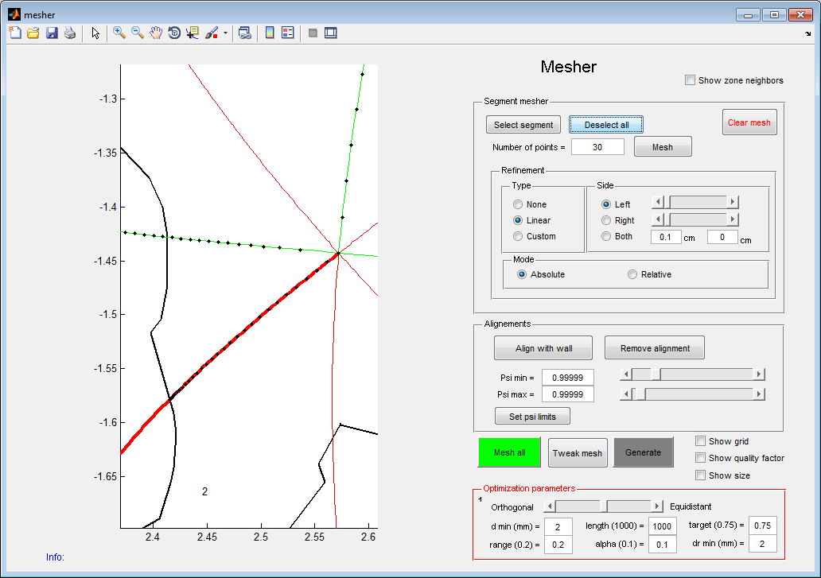

Specification of grid alignment in the absolute mode: The grid spacing is set to 1mm close to the wall here

Once a segment is meshed, all the segments parallel to it are also meshed and turn green. Repeat the operation until all segments turn green. Then proceed to subdomain meshing by pressing the “Mesh all” button. The meshing operation may take a few minutes.

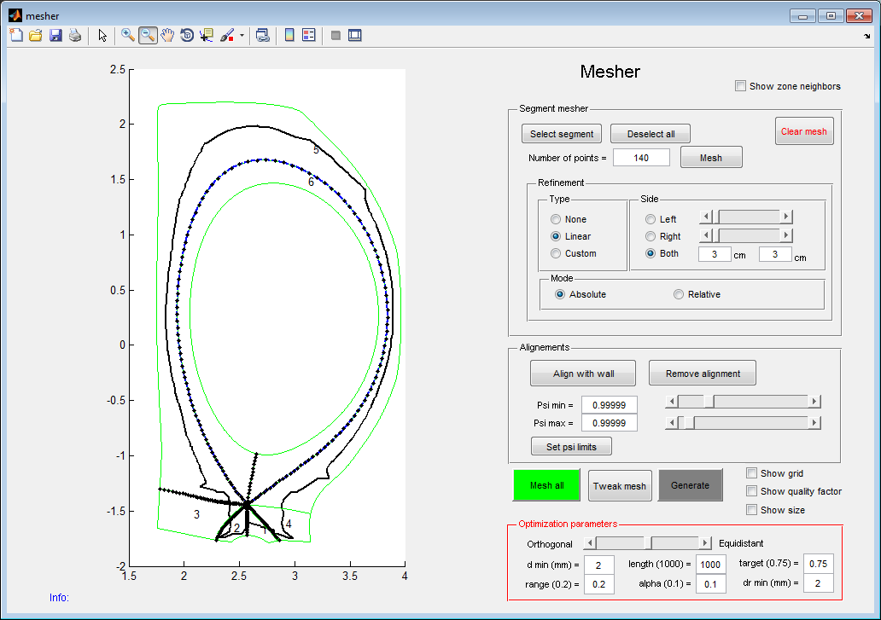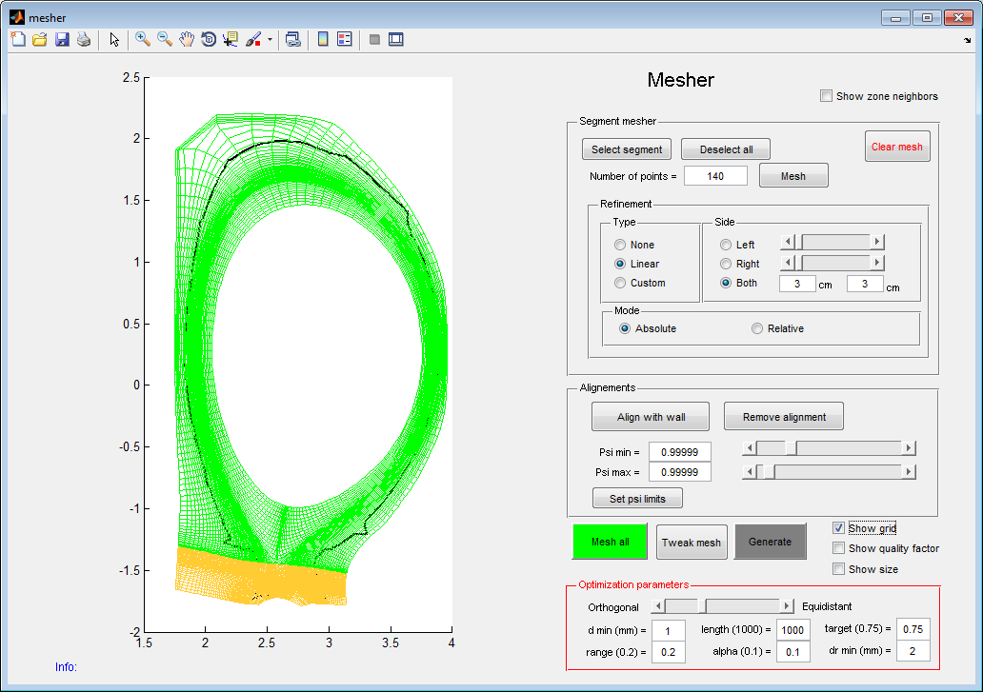

Once the grid is generated, it can be displayed by checking the “show grid” check box. Regions meshed using an orthogonal algorithm are displayed in green. Regions meshed using a non-orthogonal optimized algorithm are displayed in yellow. Optimization settings can be adjusted in the “Optimization parameters” panel. In particular, the smallest mesh allowed in the poloidal direction can be tuned setting “d” in mm. The smallest mesh allowed in the radial direction can be tuned in the “dr” textbox.

Mesh cells can be quite deformed resulting in numerical imprecision. The grid quality can be displayed by checking the “Grid quality factor” checkbox. Grid cells displayed in red may lead to numerical errors and crashes. A minimum quality factor of 0.3 is required to ensure code stability. By checking the “show size” checkbox, one displays the size of the smallest mesh cells. Too small cells may reduce the time step. The mesh can be “tweak” to widen these too small mesh cells by setting “d” and “dr” in the optimization panel and by pressing the “Tweak mesh” button. Widening mesh cells in the radial direction results in modifying artificially the magnetic geometry and must thus be used carefully.

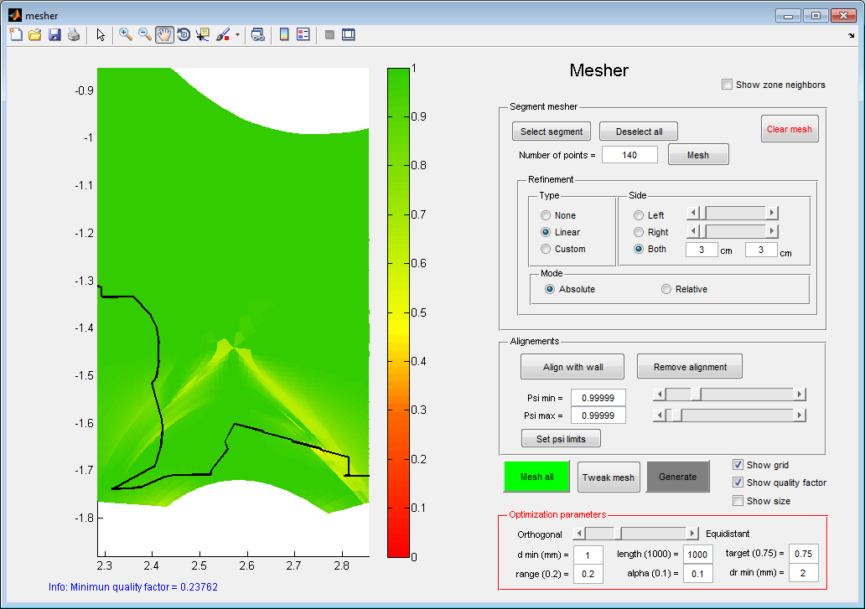

Quality factor is computed using mixed product of the base vector of the mesh cell. If will drop when the mesh is not orthogonal (typically in regions where the mesh is aligned with the wall)

In this case, the minimum quality factor is 0.23 and corresponds to mesh cells displayed in red in the solid near the outer strike point. In this case, it is due to the jump between the different Tile 5 stacks.

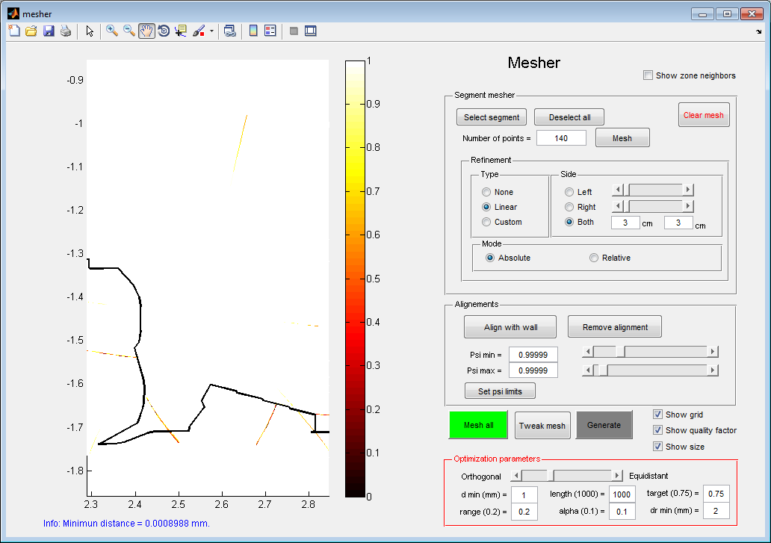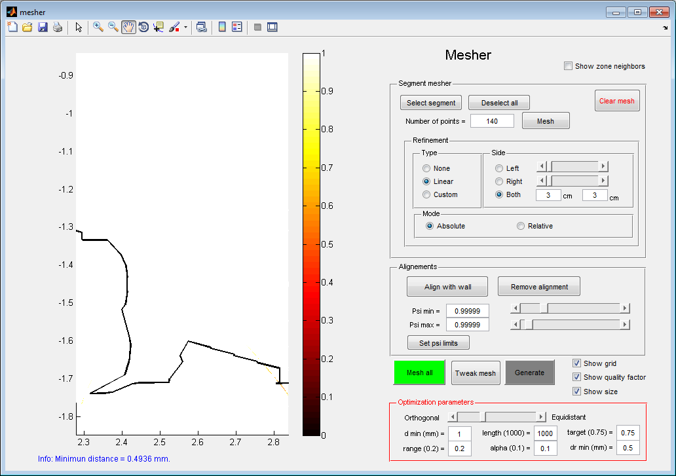

By checking the “show size” checkbox, the smallest mesh cells are highlighted. The minimum size is displayed below the figure.

To avoid too small mesh cells, it cheat trick may be done to widen the smallest cells. The smallest radial and poloidal sizes are set in the optimization panel and then the “tweak mesh” button can be pressed. In this case, one manage to remove small cells that would have reduced too much SOLEDGE2D time step.

When the meshing is finished, the “Generate” button can be pressed to open mesh files generator for the last step.

## Generating mesh files for SOLEDGE2D-EIRENE

In the mesh file generator, the window is split between the SOLEDGE grid on the left hand side and the EIRENE grid on the right hand side. On the SOLEDGE side, one can display:

* Grid points and cells
* Magnetic fields
* Penalization masks
* Radial and poloidal coordinates

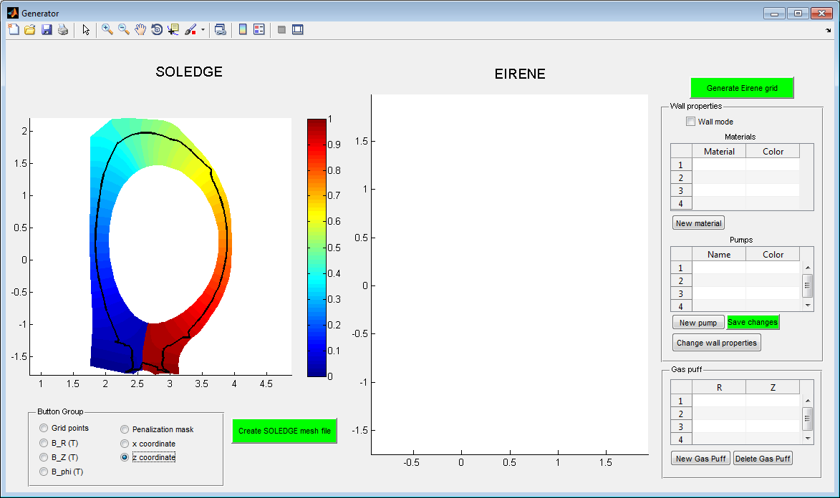

The HDF5 mesh file for SOLEDGE is simply create by pressing the “Create SOLEDGE mesh file” button. This mesh file can already been used in SOLEDGE as a standalone plasma grid. To use EIRENE, one must generate a triangle based grid and interpolation weights between EIRENE grid and SOLEDGE grid. This is done by pressing the “Generate EIRENE grid” button. Generating EIRENE grid may take some time. The resulting triangles are then displayed in the EIRENE grid panel:

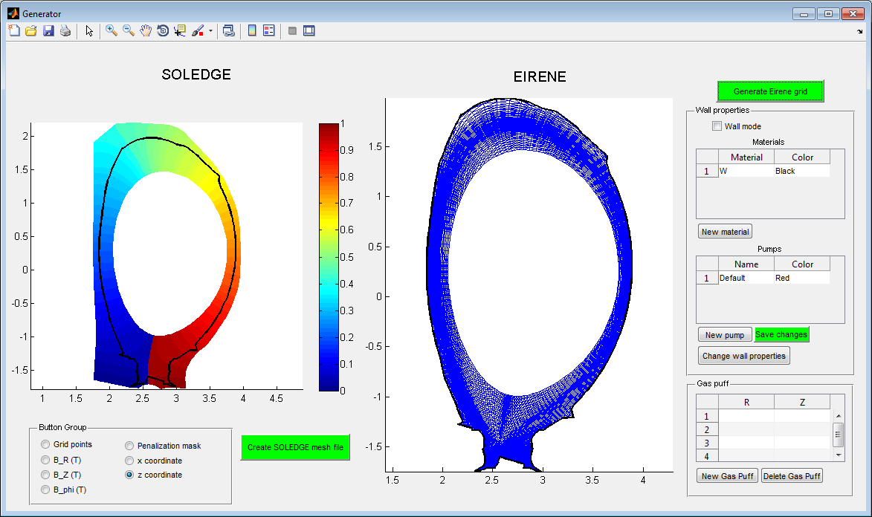

The last step consists in adjusting wall properties and gas puffs locations. To adjust wall properties, check the Wall mode check box. As default, the wall is made of one single material. No pumps are present. To add a new material in the list, click “New material”. To select regions where the new material applies, select the material in the material table and press the “Change wall properties” button. In the dialog window, select wall and then click on the wall in EIRENE figure following roughly the contour where the new material is present.

The same operation can be done with pumps using the pump table.

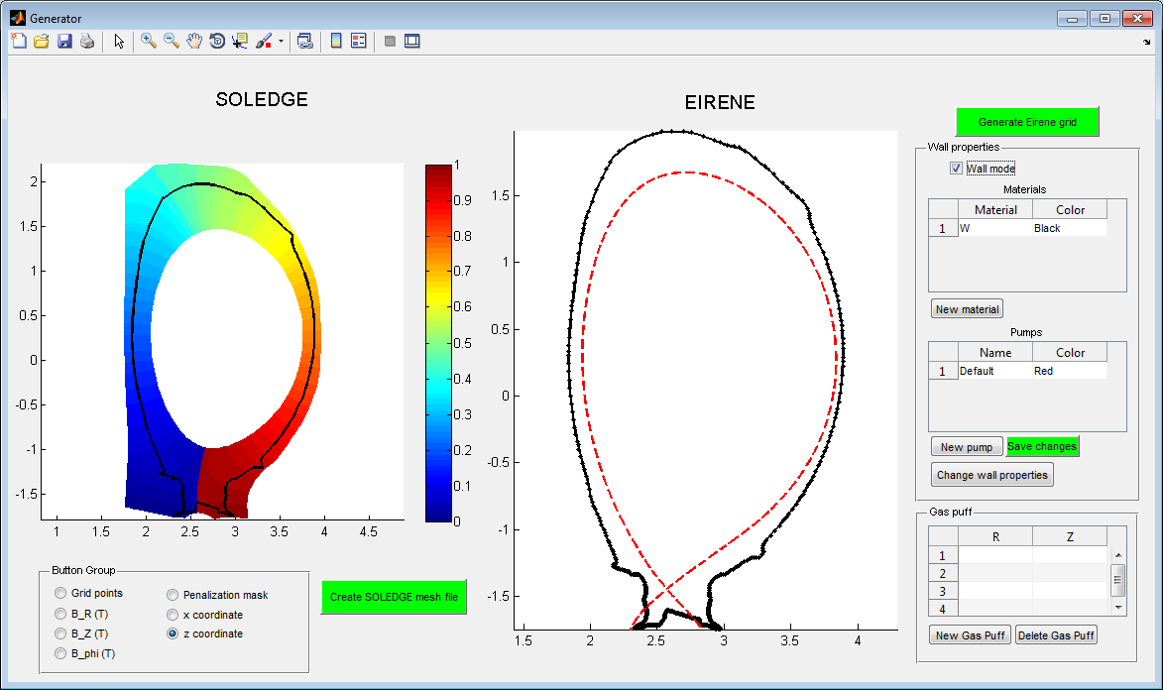

1. Default wall mode: single material and single pump that applies nowhere.

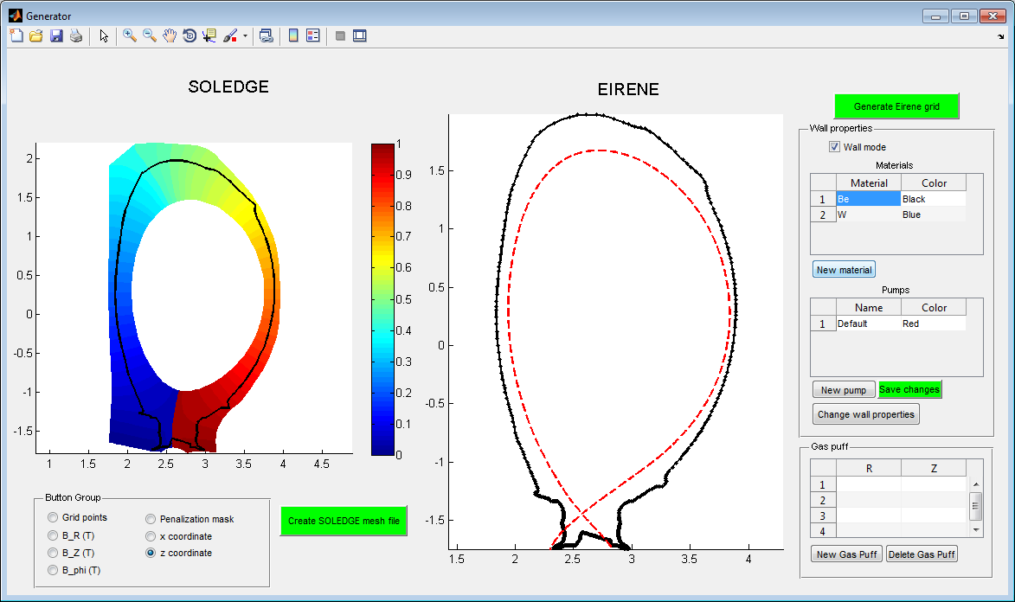

2. A new material is added and material 1 is changed from Tungsten to Beryllium.

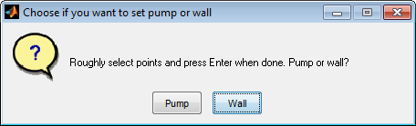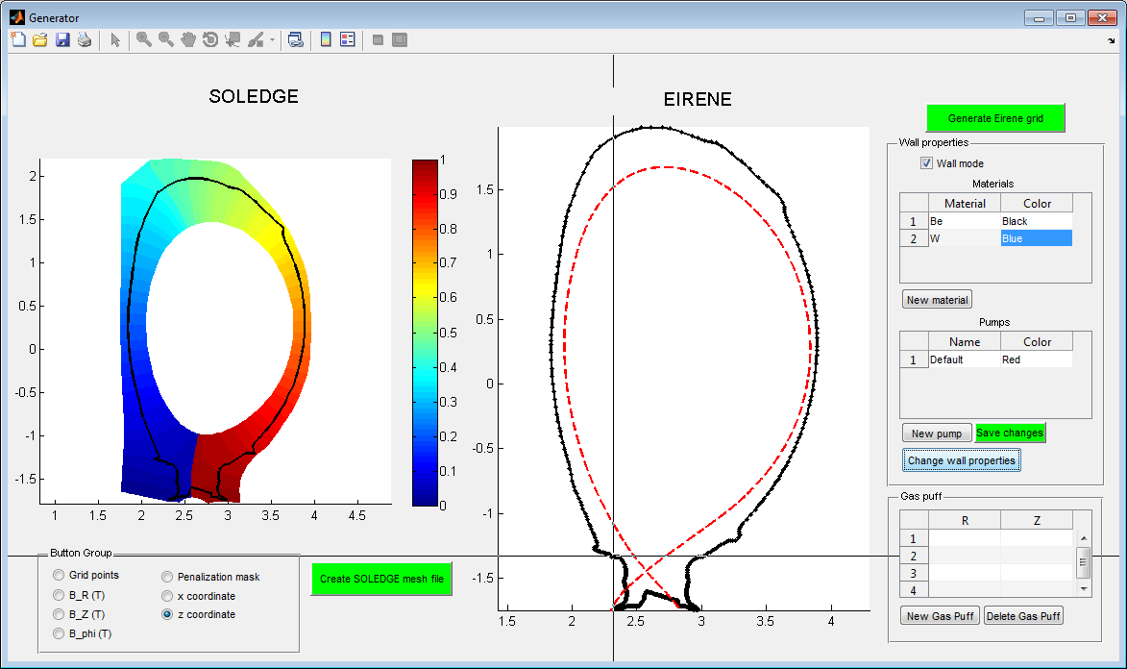

3. Material 2 is selected and one clicks the “Change wall properties” button. “Wall” is selected in the dialog box and one follows the divertor contour to switch Be to W in the divertor. **One must press Enter to finish selection.**

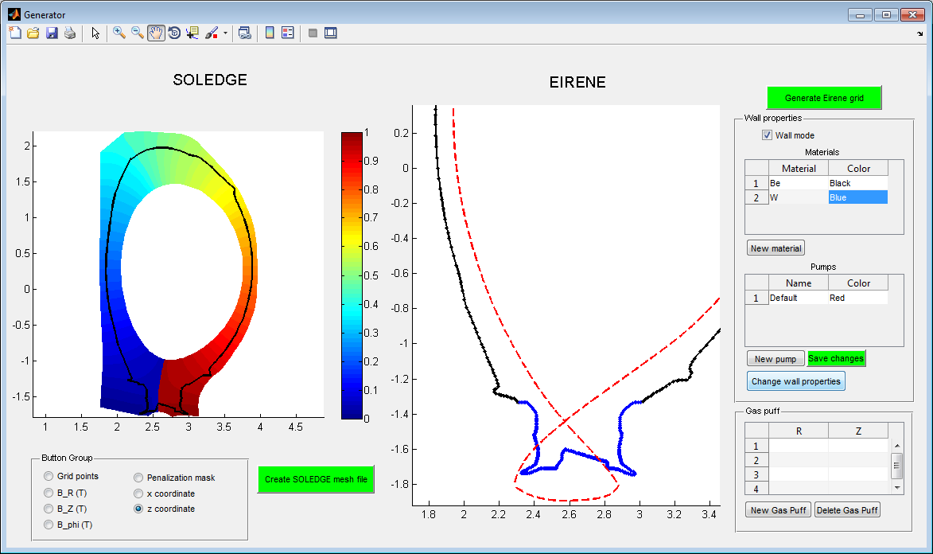

4. When the selection is finished, the part of the wall in W now appears in blue.

The same operation is made with pumps to set pumping surfaces in the corners of the divertor (pump appear in red)

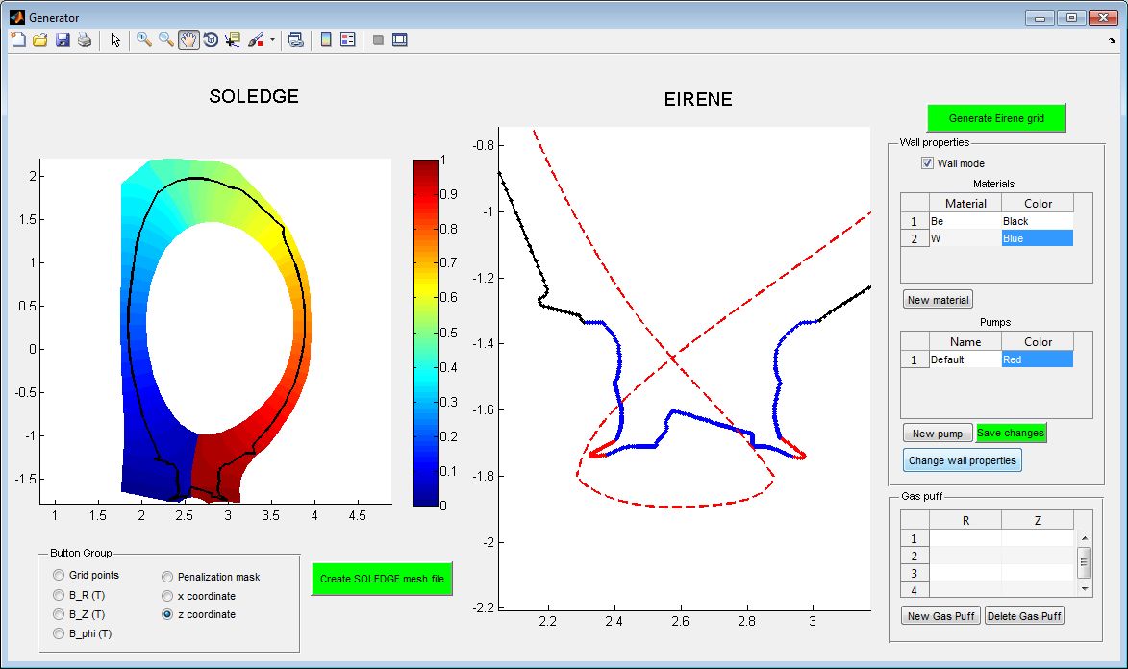

Finally, one can add a puff by pushing the “New gas puff” button. One clicks on the figure where the puff is to be added. Puffs appear in Pink on the wall.

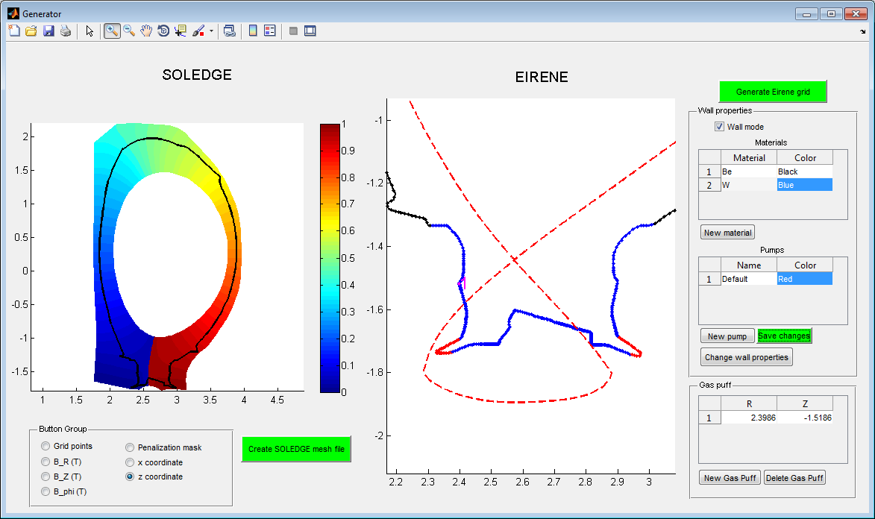

To update Eirene mesh files with the new puffs and wall properties, press the “Save changes” button. Puff information will be stored in the “Puffs” files.

**All the files have been generated and are now ready to be used in SOLEDGE2D-EIRENE !**